- Network Topologies

Q.1 Draw and label diagrams of star, bus, and mesh network topologies on paper or using any drawing tool. For each, write one real-world app or service (like WhatsApp, Flipkart, or IPL streaming) that could use that topology and explain why in 1-2 lines?

Answer

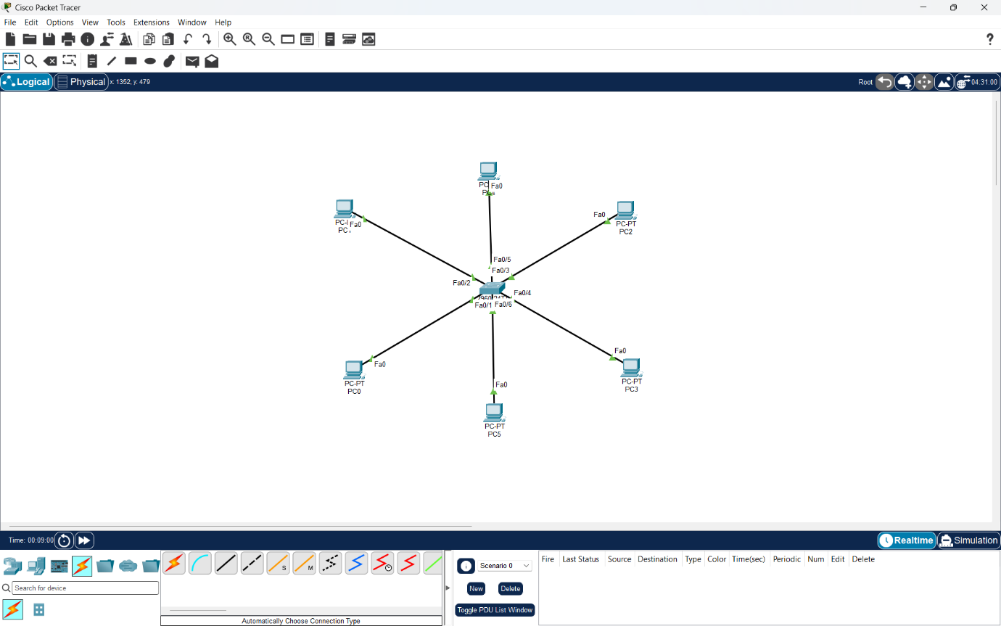

- Star Topology
In a star topology, all devices are connected to one central switch. If one PC or cable fails, the other devices can still continue working.
Real-world Example: Flipkart Warehouse Network
A Flipkart-style warehouse can use a star topology to connect order-processing computers to a central switch. It is easy to manage, troubleshoot, and expand.
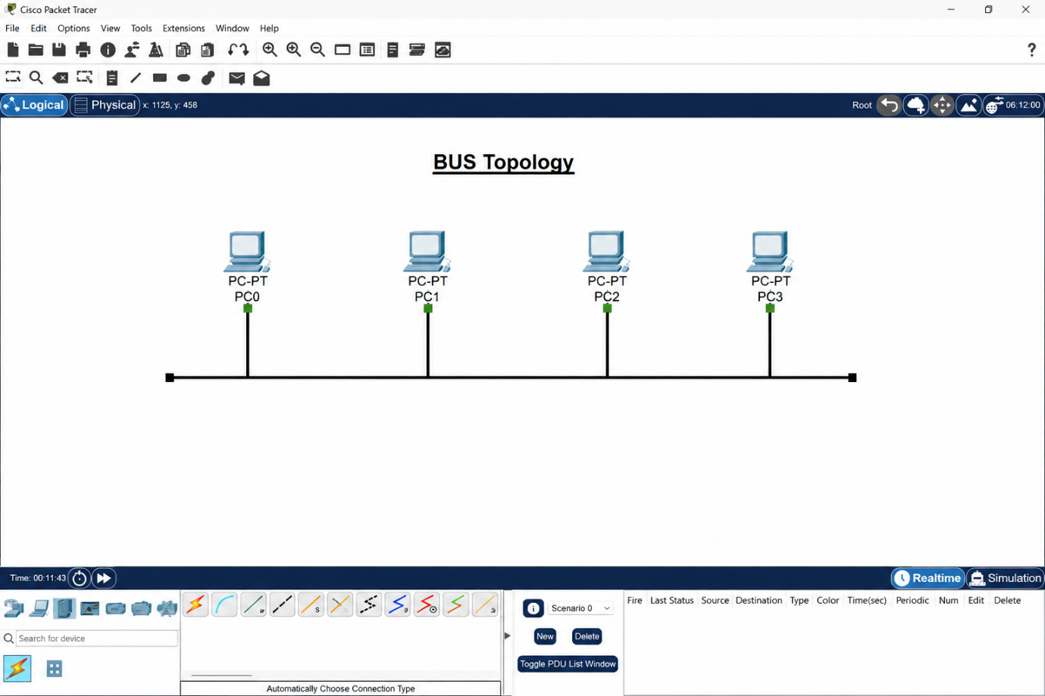

- Bus Topology – Example: Small temporary network
In a bus topology, all devices are connected to a single main backbone cable. It is simple and low-cost because it uses less cabling.
Real-world Example: A small temporary network for an event or simple office setup could use a bus-style layout because it is easy to set up, but it is less reliable if the main cable fails.

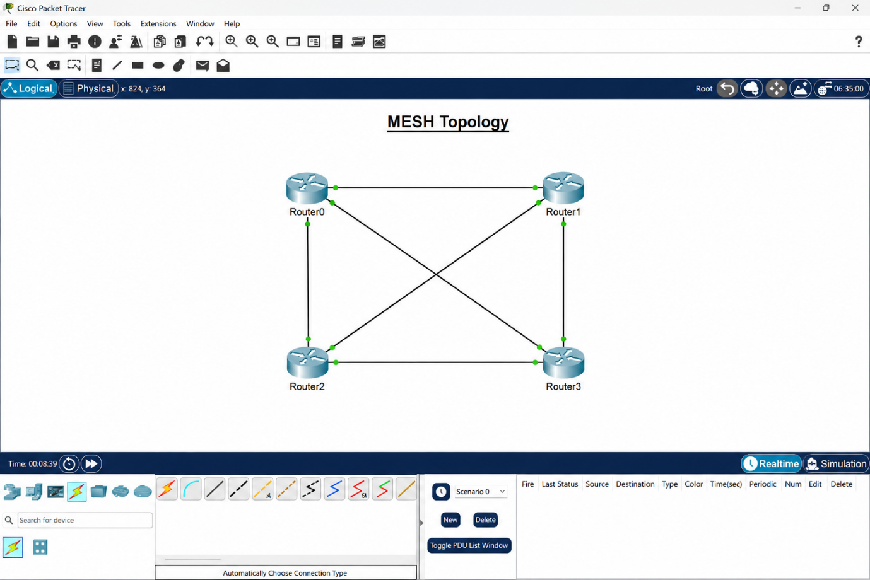
- Mesh Topology – Example: WhatsApp Server Network
In a mesh topology, each device or router has multiple connections to other devices. This makes the network highly reliable because data can use another path if one connection fails.
Real-world Example: A large service like WhatsApp can use mesh-like connections between servers or data centers to improve reliability and keep communication available.

Q.2 Create a comparison table listing at least four pros and four cons for each of these topologies: star, bus, ring, mesh. Include a column for 'Best Use Case' and give an example from apps you use (e.g., Instagram, Zomato, Paytm)?

Answer
Topology | Advantages | Disadvantages | Best Use Case
- Star | 1. Easy to install  2. Easy to troubleshoot  3. One device failure does not affect others  4. Easy to expand | 1. Central switch failure affects the network  2. More cabling required  3. Switch adds cost  4. Performance depends on the central device | Flipkart warehouse network for connecting many computers to a central switch
- Bus | 1. Low cost  2. Uses less cable  3. Simple design  4. Easy for very small networks | 1. Main cable failure affects all devices  2. Difficult to troubleshoot  3. Performance decreases with more devices  4. Limited expansion | Small temporary network for a simple event or small office
- Ring | 1. Data moves in an organized path  2. Fewer data collisions  3. Equal access for devices  4. Predictable performance | 1. One connection failure can affect the network  2. Difficult to expand  3. Troubleshooting is harder  4. Less common in modern networks | Controlled industrial network where devices communicate in a fixed order
- Mesh | 1. Very reliable  2. Multiple paths for data  3. High fault tolerance  4. Network can continue if one link fails | 1. Expensive  2. Requires many connections  3. Complex to configure  4. Difficult to manage in large networks | Paytm or WhatsApp server network where high reliability and continuous availability are important

- Conclusion:
Star topology is simple and easy to manage, bus topology is low-cost, ring topology gives organized communication, and mesh topology provides the highest reliability.

Q.3 Imagine you are designing a new multiplayer mobile game like PUBG or Free Fire. Choose a suitable network topology for the game servers and justify your choice in 3-4 lines, mentioning how it would impact speed, reliability, and cost?

Answer

- Suitable Network Topology for a Multiplayer Mobile Game
For a multiplayer game like PUBG or Free Fire, I would choose a Star topology with players connecting to a central game server or server cluster.
This topology provides good speed because each player communicates directly with the central server. It is easy to manage and can provide good reliability when backup servers are used. The main disadvantage is higher cost, because powerful servers and backup systems are needed to handle many players.

Q.4 Given this scenario: A small Flipkart-style warehouse wants to connect 8 computers for order processing and inventory updates. Recommend a network topology, sketch a quick diagram, and explain your reasoning in 2-3 lines.<br><br><em><strong>Hint:</strong> Consider factors like cost, ease of troubleshooting, and future expansion.</em>?

Answer

- Network Topology for a Flipkart-Style Warehouse
For a small warehouse with 8 computers, I would recommend a Star topology.
In a star topology, all computers connect to one central switch. This makes the network easy to manage, troubleshoot, and expand. If one computer or cable fails, the other computers can still continue working.
- For the diagram, show:
- 1 central switch
- 8 computers connected separately to the switch
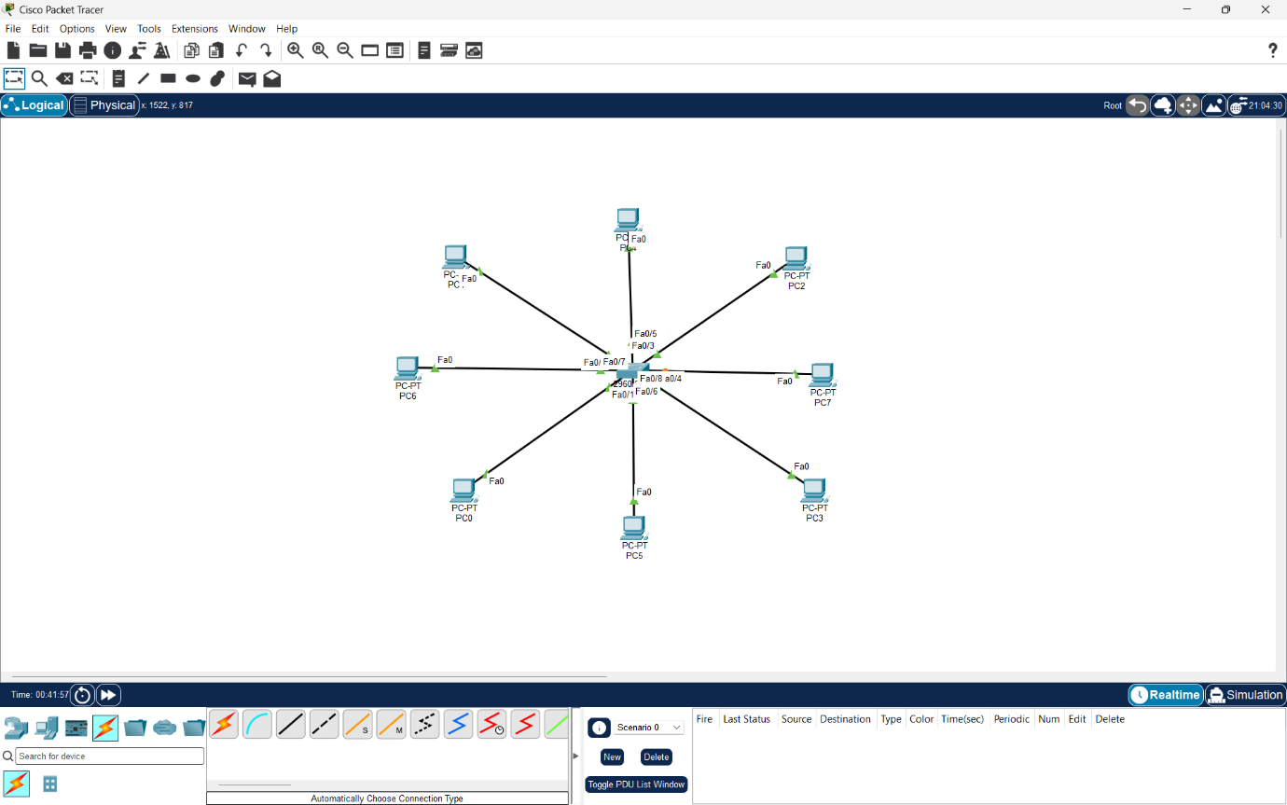
- Reason:
Star topology is suitable for the warehouse because it is reliable, easy to troubleshoot, and simple to expand when more computers are added.

